Appendix 7: New Features in V 3.5
Port Flow Analyzer has had many updates since this user manual was written for the original v3.0 for Windows. These include
3.0 A through v3.0 E and now v3.5. Here is a brief listing of some of the features new since v3.0 E was released, including Version 3.5. Unless stated, most all of these new features apply Only to the Pro Version of the software:

New Features:
- The program now has an “EZ Start Wizard” to walk beginners through the steps of starting a new test. (Fig A20) This feature is in the Basic version also.
- Program will automatically look for old v3.0 files and copy them over to this new v3.5. This feature is in the Basic version also.
- Added several features for emailing graphs, files and PDF reports (if you have the full Adobe Acrobat ™). (Fig A21)
- Program now has a 'Website' button in the About screen for jumping to www.performancetrends.com website.
- New Preference for Blue and Red text colors in data entry grid on main screen, to better remind user of Intake versus Exhaust data. This feature is in the Basic version also.
- Increased the number of possible data points (rows of data) up to 55. This feature is in the Basic version also..
- Program now has added a new 'Edit' menu with several Edit options for the Main Screen. (Fig A22) This feature is in the Basic version also..
- Program now has added Backup and Restore commands under File at the main screen. (Fig A22) This feature is in the Basic version also..
- Program now has added ability to read WinFlow files from SF 1020 bench, in addition to an SF 600.
- You can now resize the Electronics and FlowCom Recording screen to display these readouts to fill the entire screen, if needed. (Fig A33) This feature is in the Basic version also..
- The program now warns if you pick an Alternate Folder for Saving in Preferences if the path includes "\PFADAT". You should be picking the folder which contains the folder "\PFADAT".
- In Head Details screen, the program would not correctly calculating Area or Width and Height for an Oval port. The program assumes Oval if the Width and Height are not the same and "Round" is the port shape described in the Head specs.
- The main screen now displays better for screen resolutions greater than 600 x 800. This feature is in the Basic version also.
- The screen colors are now more compatible with Windows XP. This feature is in the Basic version also.
- Added a new Port Velocity mode in test options, where you can record 1 pitot tube pressure at every test point. A new Preference called "Prompt for Recording Single Vel. Pt." was also added to let the program Prompt you for recording a single Pitot Tube velocity reading after you record the CFM readings. Set this to No and the program records all data AND Pitot Tube velocity at the same time. Set this to Yes, and the program records all CFM data EXCEPT velocity, then displays a message "Now Record Velocity with <F1>" for about about 1 second, then when you press <F1> again, just the velocity reading is taken. This data is contained in a data column called “Vel #1”. This data is graphed vs Lift or L/D if you select to graph a Port Velocity Map, and is included in Report Types of “Raw Data” and “Calculated Data”. (Fig A23)
- You can save a picture file (like a jpg file) at each lift point, like recording flow patterns with wet flow benches. (Fig A23)
- You can now search (Filter tests) for certain characters or phrases in the test File Name, in addition to comments, spec settings flow results as available in v3.0.
- Now when you click on a graphed point on the main screen, the row for that data point gets highlighted in the table of results. This feature is in the Basic version also.
- Program now better remembers the printer type and printer page orientation when you make changes to the Windows Printer Setup. This feature is in the Basic version also.
- Program now has new preference to let you pick a Company Logo graphics file to appear in your printouts. The logo prints out in Graph printouts also. (Fig A25)
- Updated the routine to locate an appropriate version of Adobe Acrobat ™ to view the PDF files for the user manual. This feature is in the Basic version also.

New Outputs (Features for Graphs and Reports):
- Added several new features for doing Cylinder to Cylinder comparison reports. (Fig A24) When you choose a 'Cyl-Cyl' report type, three new options appear:
  - Whether to include additional Tests or Heads in the report. This allows you to compare cylinders from different tests or heads on the same report.
  - Whether to include a difference column to show the difference in the first Column of CFM to all the rest. This first column could be a single cylinder or the average for the first head.
  - Whether to include averages of the columns at the bottom of each column. This would be like the average CFM flow at all lifts for each cylinder.
- Program now has added ability to specify which Ports to Graph and/or Report with a new 'Pick' option for Which Cylinders in the 'Graph' and 'Report' Options screens. (Fig A24)
- Columns in History Log have been slightly rearranged, and columns now include Which Cylinders, which are the cylinders to Report or Graph if you choose the 'Pick' option. (Fig A24)
- New Format option to Open/Save/Edit a particular graph format. This allows you to save the graph type, test pressure corrections, graph scales, etc to a particular name. Then you can easily Open these saved formats to reproduce a graph format in the future. This is available by clicking on Format, then Open/Save/Edit Graph Format. (Fig A26)
- User Specified Colors now include colors for Port Velocity Maps. Click on Preferences, then Set Graph Colors on the right side, then at the bottom right of the Graph Colors screen are the color choices for the Port Velocity Maps.
- Made several changes so Port Velocity maps would show up better on various computer screen resolutions.
- Added several new features for writing ASCII files from reports. (Fig A29)
  - Report names can now include the path.
  - Now you can browse to find or create a file name and path for writing the ASCII file.
  - ASCII reports can now include comments and all test specifications in the output.
  - Program now remembers ASCII file settings.
- Program now has added several additional graph styles under format, then Line Style. These include bar graphs, 3D bar graphs, area graphs, etc. (Fig A27)
- Program now has added "3D-Graphs.clc" calc screen to let user change view and other specs about 3D graphs. (Fig A28)
- When opening a WinFlow data file, the program now lets you pick the Comments file for this WinFlow file, so those comments can be imported also.
- The Preference which allows you to choose a default Floppy/CD drive has been expanded to include letter drives from A to
Z. This feature is in the Basic version also.
- Changed Preference for Dot Matrix Graph Printer Adjustment to "Graph Printer Adjustment For..." and now have "Acrobat" as a choice. This feature is in the Basic version also.
- Put in checks for blank choices in Graph and Report menus. Blank entries are automatically set to the first choice in the 'Drop Down'. This feature is in the Basic version also.
- Made graph line flash rate independent of computer speed (.2 second flash rate). This feature is in the Basic version also.
- Print B&W now draws graph as B&W on screen for better printing on color printers when B&W has been requested. This feature is in the Basic version also.
- Program now prints headers of graphs and reports the same, and modifies the spacing to better ensure that long test file names are printed completely. As mentioned earlier, you can also include a company logo graphic image.
- A new option has been added so reports can be printed WITHOUT the Flow Data. This allows you to print, for example, just the Head Specs and Head Details with nothing else. This feature is in the Basic version also.
New Features for Various Flow Benches and Electronics:
- Added some new Flow Bench types and/or features to be more compatible with the following types of Flow Benches. This feature is in the Basic version also.
  - Performance Trends’ EZ Flow system. (Fig A32)
  - SuperFlow
  - FMA Flow Benches from Australia
  - Saenz Flow Bench
  - Performance Flow and JKM style benches (using Pitot Tubes to record CFM flow)
  - Several styles of custom or “do it yourself” flow benches.
- Program now will control Performance Trends’ automatic Valve Opener. Note: You will be given a new unlock number for your program to open up the Valve Opener menu option in the Flow Bench specs. (Fig A30)
- Program is compatible with SuperFlow's ™ new USB FlowCom. This feature is in the Basic version also.
- Added 3 new Preferences for Pro version only, which allows for there to be both an Intake and Exhaust Test Correction. A Test Correction is obtained by flowing a known orifice where the head would go on your flow bench. Knowing the difference between what IS measured and what SHOULD BE measured, a correction is obtained, to put your bench back in Calibration. Now you can do this both in the standard Intake direction AND exhaust direction. The Preferences menu now contains places for you to enter the expected flow for both the intake and exhaust direction. Previously, the program used the Superflow SF110 bench standard of 153.2 CFM.
- Program now has added ability to permanently save some debugging settings in the 'Flow Com' or 'Electronics' screen if these debugging settings are fixing a problem. Click on Options, then the 'Save..' or 'Unsave...' options.
- Program now has added option if FlowCom screen to force FlowCom to change the range of the flow bench.
- If requested Range in Bench Specs is blank, the program now assigns range 1 both in the FlowCom Screen and in the Main Screen grid (spreadsheet).
- Added Calibrate Range screen in Bench Specs for Custom Bench or Performance Trends’ EZ Flow Type flow bench. By installing and flowing known sharp edged orifices, you can calibrate your bench to match the CFM results of other production flow benches, like a SuperFLow ™ bench. (Fig A31)
- Program now does more extensive of valid com ports for communicating to a FlowCom or Performance Trends Black Box and Black Box II. It checks up to Com Port 20, and gives better suggestions at valid ports. There is also a “Find” button in the Flow Bench specs screen to find your electronics by checking all available Com Ports. This feature is in the Basic version also.
- Expanded some allowable ranges for SF300 and SF600 to cover ranges requested by some customers. Opened up acceptable limits for flow ranges for Custom Bench to 10-5000 CFM. This feature is in the Basic version also.
- New Preference allows you to increase the allowable test and flow pressure inputs up to 1000 each.
- Program now allows printing of Calibrations screen. This feature is in the Basic version also.
- Rearranged Troubleshooting options in FlowCom/Electronics screen to be under Help. This allows more room for features to be listed under Options. This feature is in the Basic version also.

New Features Specific to the Black Box II:
- Program now has added option for Recording Switch for Black Box II. Click on Options in the Electronics screen, then Foot Switch Enabled to turn on this option. Then click on Options in the Electronics screen again, BB2 Foot Switch, then pick which Temperature channel to have the switch come in on. The Black Box II can read both temperature and the foot switch from the 4 pin analog inputs on its side. This feature is in the Basic version also.
- Added 2 new Troubleshooting Options, of Test Com Ports and Check Boot Message. This feature is in the Basic version also.
- Made major change to EZ Flow flow bench calibration to work with new Black Box II. (Fig A32) This feature is in the Basic version also.
- Program now does better checks for bad data from Black Box II. This feature is in the Basic version also.
- Added new option for Preference of 'Black Box Reads +/- Pressure' but the program does no checks to see if the direction of the flow is correct for the type of port, intake and exhaust. Setting “Black Box Reads +/- Pressure” means a custom bench does not need valves to maintain the high pressure side of the manometer to remain the high pressure side of the manometer when you switch from the Intake to the Exhaust flow direction. This greatly simplifies the design of “do it yourself” and custom benches.
- Fixed bug where if the program is set to 'Black Box Reads +/- Pressure', CFM was being displayed even if the Vertical Manometer reading was less than 2" water. This feature is in the Basic version also.
- Added Preference for Barometer sensor in Black Box II. To get Barometer reading with Black Box II, you must turn on the Preference "Black Box II has Baro Sensor" and also ask to record Barometer in the Test Conditions screen. You can also adjust the Barometer reading slightly with the Weather Calibration section in the Calibrations screen available by clicking on the Calibrations button at the lower left corner of the Flow Bench Specs screen. The Barometer input in this screen will offset the Black Box's barometer reading. For example, enter -.25 and the Black Box's Barometer will be reduced by .25 inches of Mercury.
- Program now has added checks for Black Box or EZ Flow systems to watch for over-ranging the pressure sensors, producing inaccurate data. For example, if a pressure sensor is “maxed out”, the program tells you this, rather than letting you think this data point is accurate. This feature is in the Basic version also.
- Fixed a bug where the Black Box could read test pressure incorrectly for certain faster computers. This feature is in the Basic version also.
- Added a Preference to Eliminate program looking for Black Box set up for + or – pressure.

New Engine Performance Report Features (Pro Version Only):
- Program now comes with almost 1000 more example cam profiles built in, including almost the entire Crane catalog.
- Program now offers to fill in blank Engine Specs.
- Program now allows for Rocker Arm Ratios of less than 1, down to .7
- Fixed a bug where if you chose a different Cam Advance in the Engine Specs screen, it would blank out and revert back to straight up.
- Fixed a bug where if you chose something other that .050" events in the Engine Specs screen (.040" or seat timing), the program would always open up the Engine Specs screen with .050" as the labels for cam events.
- Fixed bug where VERY high runner velocities (small ports) could erroneously produce good HP.
- Engine Performance Estimate report now uses Metric Units if Metric units are chosen in Preferences.
ing the EZ Start Wiza
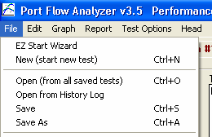
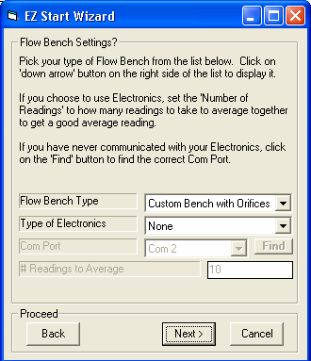
Fig A20 Starting a New Test Usrd
Click on File, the EZ Start Wizard to start a new flow test using the “Wizard”
You will be presented with a series of screens with questions, explanations and possible settings, to make starting a new test as easy as possible. “Back” button at bottom lets you easily back up to previous steps.
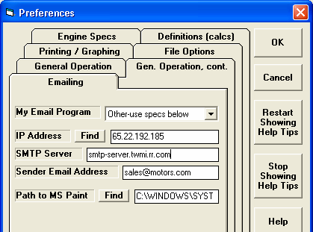
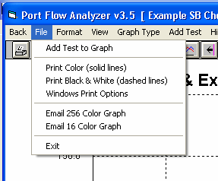
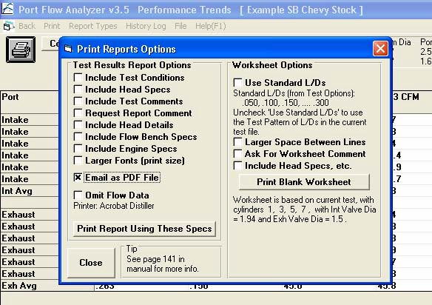
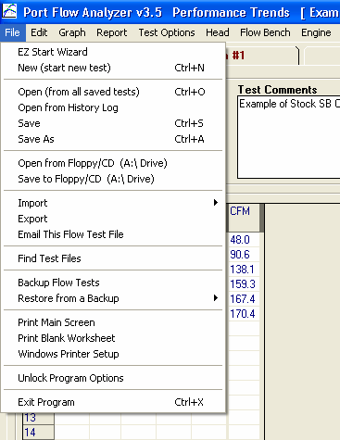
Figure A 21 Emailing Options
Email as PDF File in the Print Options in the Report Screen.
Email a Test File from the Main Screen, so someone else with Port Flow Analyzer can view it.
Email options in Graph screen. The Email 16 Color Graph requires you to find MS Paint utility on your computer and will create a smaller file for emailing with very little loss in picture quality.
Set email options in Preferences. Click on Help button on right for explanation of these features.

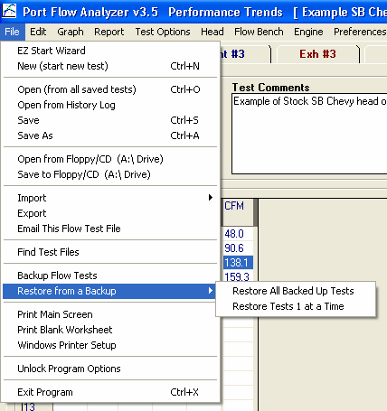
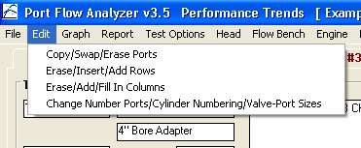
Figure A22 Some New Features on the Main Screen

New Backup and Restore Commands let you backup or restore ALL your test files with a couple of keystrokes.
New Edit Options
New Import Commands to import WinFlow ™ files (SF 600 and SF 1020) and import files from an earlier version of Port Flow Analyzer, like v3.0. This makes it easy to pull all your v3.0 files over to the new version 3.5.
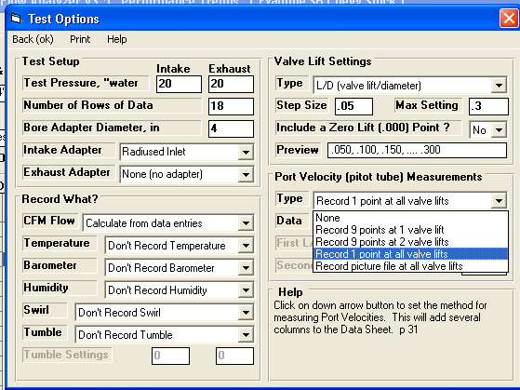
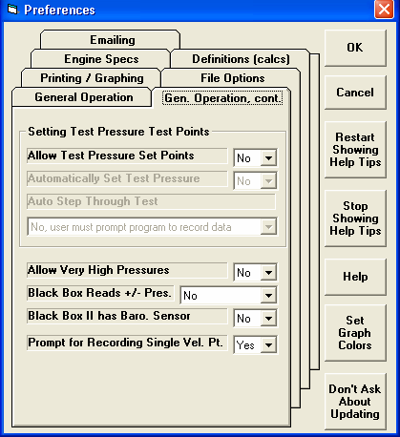
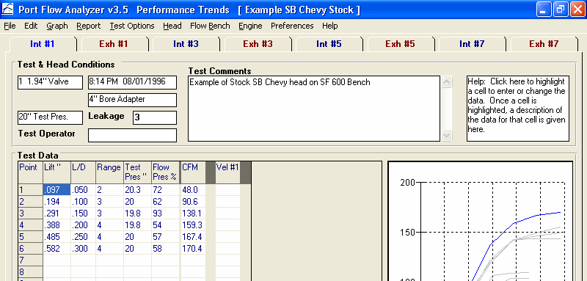
Figure A23 Options to Record a Single Velocity Data Point
This is the column where your Single Velocity point will be recorded.
Choose Single Velocity Point in Test Options. Note the additional new option of Recording a Picture File for each lift point, typically used for Wet Flow Benches.
This Preference lets you pick if you want the program to Prompt you for recording the velocity point after you record CFM data.
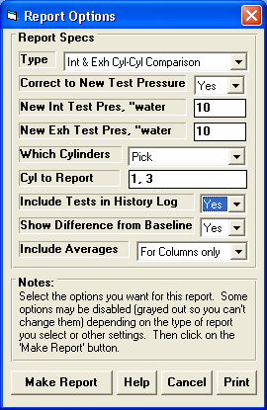
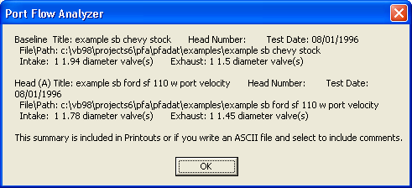
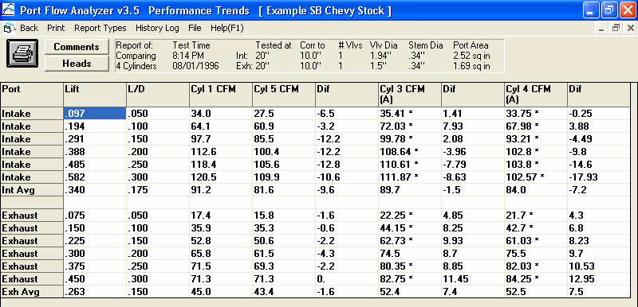
Pick a “Cyl-Cyl Comparison” Report Type.
Figure A24 New Cyl-Cyl Comparison Reports
New “Pick” option lets you specify which cylinders for this head to include, in this case you have entered “1, 3”.
These 3 new settings for “Cyl-Cyl Comparison” reports let you include cylinders from other tests, include a “Dif” column showing CFM improvements, and if you want averages of the columns or flow averages for the head included in the reports.

Click on the “Heads” button for a summary of the heads shown in this Cyl-Cyl Comparison Report, as shown here. These comments will be included in printouts.

Cyl 3 and 4 picked in History Log from Head “A” for comparison.
1st and 3rd cylinders from the Baseline head (Cyl #1 and Cyl #5 on this Chevy head) shown here, as picked in the Report Options screen.

Difference between each cylinder and the first cylinder (Cyl 1 CFM in the 4th column in this case) is shown in the “Dif” columns.
Column Averages shown at bottom of columns.
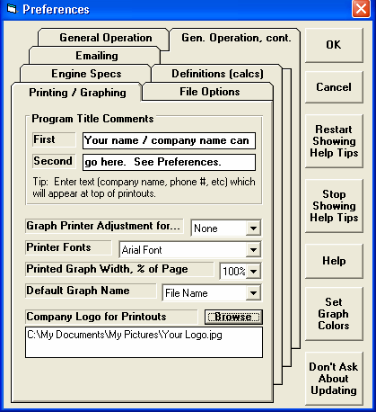
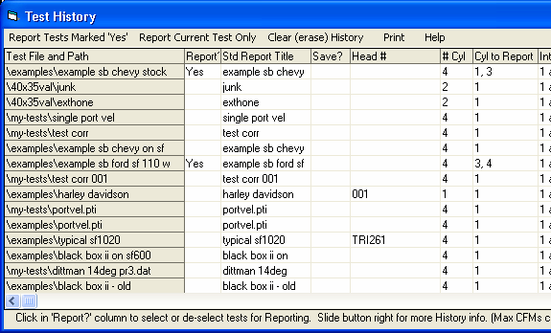
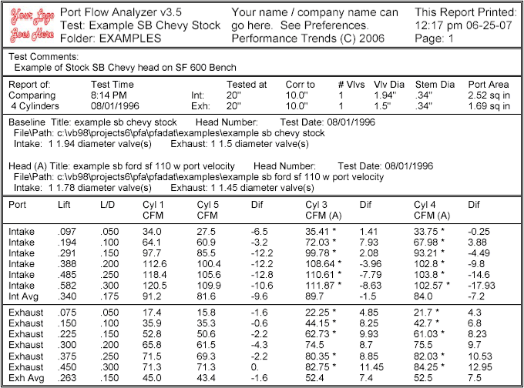
Figure A25 Print Options and History Log for Printing Report from Figure A24
In Preferences, set text to be included in Printouts.
In History Log, put a Yes in the “Report” column for tests you want to include in this report.

Click in the “Cyls to Report” to assign which cylinders to include in the “Cyl-Cyl Comparison” report.

Use Browse button to find your graphics file on this computer.
Two lines of text from Preferences is printed here in printouts.
Graphics file is drawn here on printed reports.
Cyl-Cyl Comparison Head Summaries is given here.

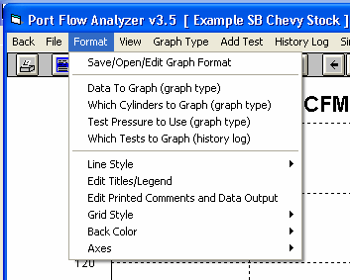
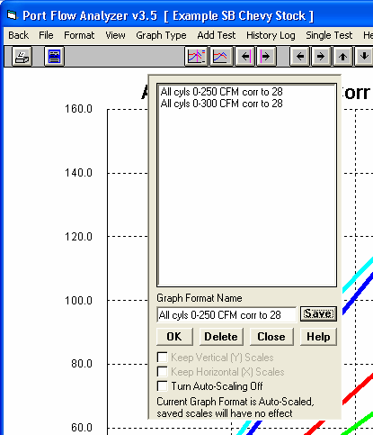
Figure A26 Saving a Graph Format, and more
Type in a name for the current graph settings, then click on Save to save them under that name and add it to the list.
Click here to allowing Saving of the current graph settings as a Format.
To open a saved format, click on the format name from the list, then click on OK. Do the same but click on Delete to delete that saved Format.
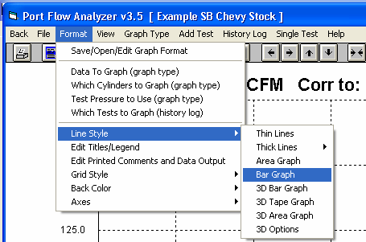
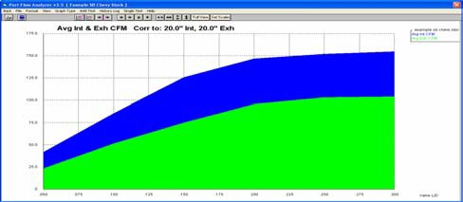
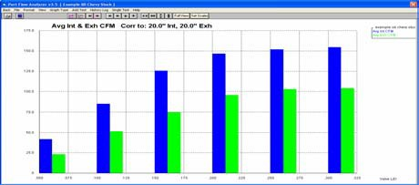
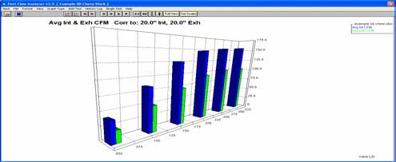
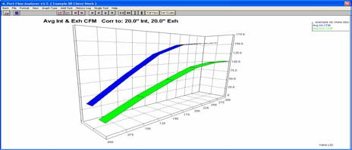
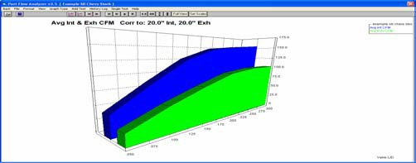
Figure A27 New Graph Format Styles
3D Options are shown in Figure A28
Click on Format, then Line Style, then choose one of these 5 new “Line” Styles.

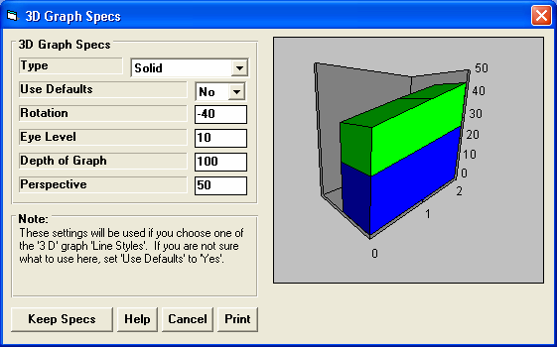
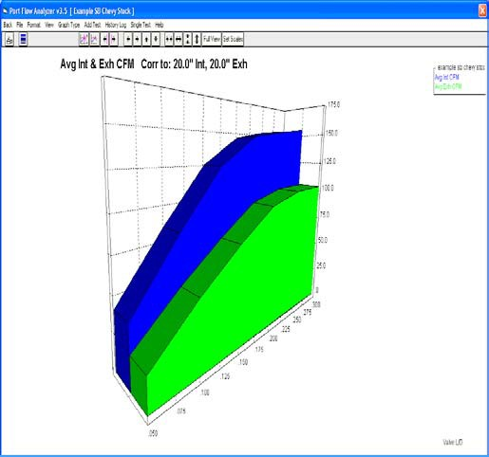
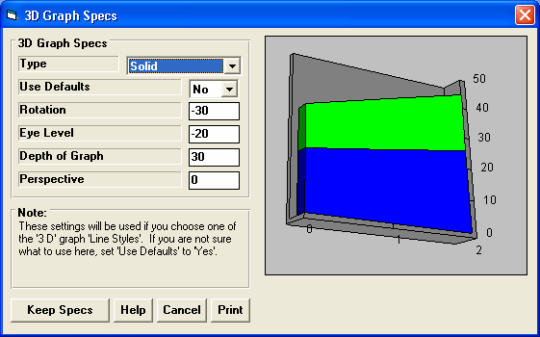
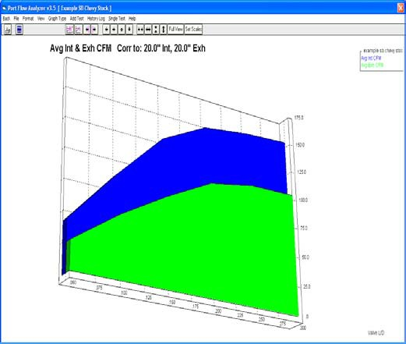
Figure A28 Using 3D Graph Options Mentioned in Figure A27
These settings make this graph.

These settings make this graph.

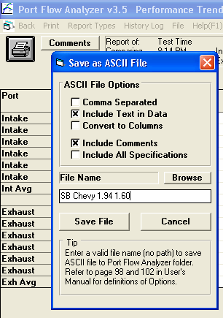
Figure A29 New ASCII File Options
Several new options have been added to writing ASCII data files for importing into other data base programs, like Microsoft Excel.
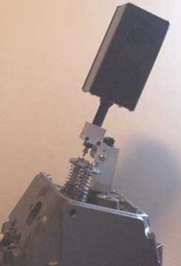
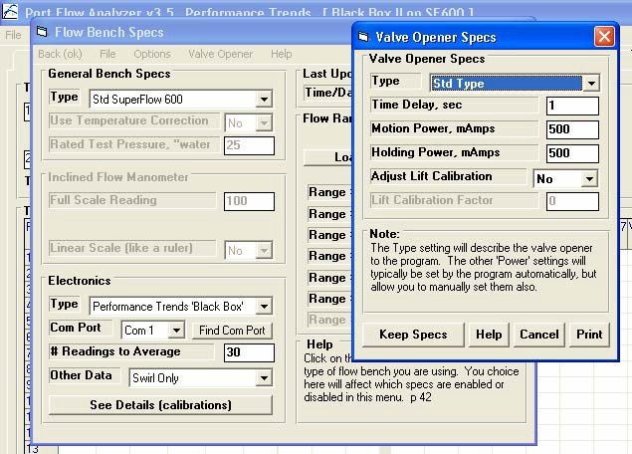
Figure A30 Prototype Automatic Valve Opener

Production unit will be about half this size, but was not available at time of printing this update.

Unit automatically finds valve stem and zero’s itself out. Then it steps through all valve lists you have chosen, returns the valve to closed position, checks for any slippage, and turns off bench.
Click on Help button for details.
Choose a Type other than “None” to use a valve opener, then enter settings.
Click here to open Valve Opener Specs screen. This option only appears if you have unlocked Port Flow Opener with a special unlocking code from Performance Trends.
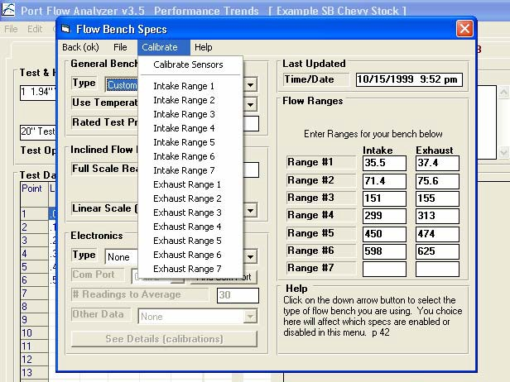
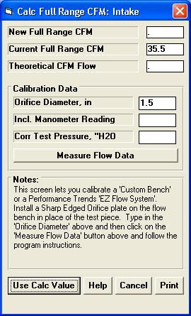
With electronics or for our EZ Flow System, you will click on this Measure Flow Data button to record the Inclined Manometer and Corr Test Pressure data electronically.
To calibrate, you will install a sharp edged orifice of a known diameter where the cylinder head typically goes. You will turn on your bench and flow this orifice as you would a cylinder head.
Without Electronics you will type in the inclined manometer reading and the test pressure across the orifice. Test pressure is the pressure typically 10, 25 or 28 inches of water).
Figure A31 Features to Calibrate a Custom Flow Bench (similar to calibrating a Performance Trends’ EZ Flow System)
Click on Calibrate, then choose which range you want to calibrate. IMPORTANT: You must calibrate the vertical manometer (test pressure) pressure sensor if you are using electronics BEFORE calibrating these ranges. It is CRITICAL the test pressure reading across the sharp edged orifice is accurate.
If you have selected a “Custom with Orifices” or “EZ Flow” style of bench, then the Calibrate menu option is made available.
Before Calibrating: For a Custom Bench, you must enter the “Full Scale Reading”, or the highest reading you can see on your inclined manometer.
Without electronics, you must also set the “Linear Scale” parameter also.

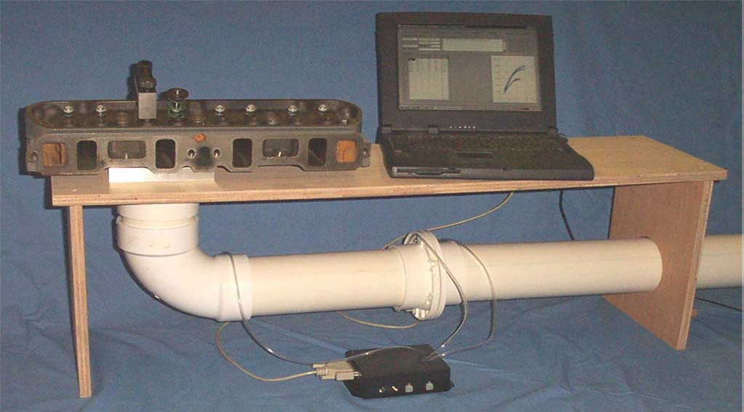
Figure A32 Performance Trends’ EZ Flow System

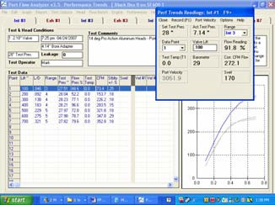
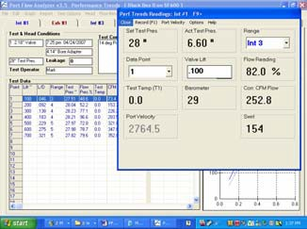
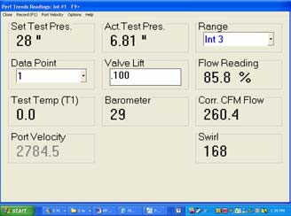
Figure A33 Resizing FlowCom / Electronics Recording Screen

Click and drag the blue title bar of screen to most any location on screen you want it.

Place the mouse pointer on the border to get a double arrow mouse pointer, then drag the border in the direction you want to expand the screen or shrink it.

